DENMARK – LAND OF THE VIKINGS

Denmark is a small country made up of the Jutland Peninsula and over 400 islands with an abundance of places to visit. From the capital city of Copenhagen where historical royal castles can be found buried amidst the surrounding forestland to the beautiful streets of Odense, birthplace of Hans Christian Andersen, Denmark truly is a land of fantasy.

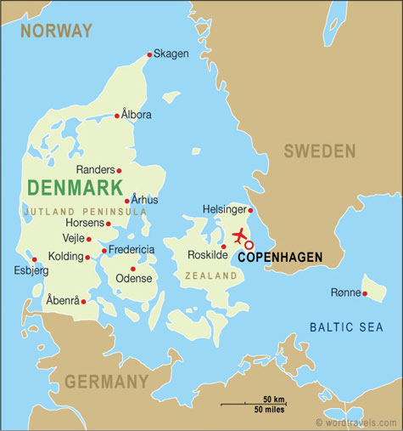

LOCATION :
Denmark is the smallest and southernmost of the three countries that make up Scandinavia, sharing a border with Germany, extending to the continent of Europe. Comprised of Jylland, Sjælland, Fyn, and over 400 other islands, Denmark is open to the North Sea on its west and the Baltic Sea on its east.
The sovereignty of Denmark also includes the massive and largely unmapped island of Greenland and the Faroe Islands.

VISA The visa is to be obtained prior to arrival in the country
HOW TO GET THERE :
International Airport : Copenhagen is the International Gateways to Denmark. Finnair has good connections to Denmark via Helsinki. Approx. flying time is 11. 30 hrs.

GETTING AROUND :
Air : There are regular airlinks from Copenhagen to international destinations, while domestic links radiate from Copenhagen's central hub. Flights can be made between most major cities in the country. Internal flights are usually of very short duration (less than an hour) and represent a great saving in time above the road and ferry network. They are not always cheap however.
Train : Denmark has a very good and reliable rail network, run by the State Railway Danske Statsbaner (DSB). Trains are extremely modern with the Intercity service providing fastest links across the country. InterRegional (IR) services are also used although these tend to be slower. Take note that all Intercity services require you to reserve a seat in advance.
The ScanRail Flexi Pass is valid for unlimited rail travel with selected rail providers through Scandinavian countries. Eurail and InterRail passes are also valid in Denmark.
Bus : The train network in Denmark outshines the bus, but for local travel you'll find the bus very efficient. What's more, the integrated transport system means that your train ticket will usually be valid for the immediate local bus zone at your destination.
City transport works on a zonal system. You should purchase your ticket before boarding and stamp it either at the stop or at the machine at the entrance to the bus or tram. On-the-spot fines are payable for failure to produce a validated ticket on demand. Copenhagen offers a particularly good range of tourist and travelcards that make using public transport extremely easy.
Distances (By Road) { Kilometres in the lower left of the table, miles in the upper right.}
• City | Cop | Hel | Mal | Ode | Esb | Ton | Arh | Aal | Leg
Copenhagen | • | 29 | 24 | 100 | 185 | 202 | 186 | 255 | 161
Helsingor | 47 | • | 61 | 125 | 210 | 227 | 211 | 280 | 187
Malmo (Sweden) | 39 | 99 | • | 121 | 206 | 223 | 207 | 276 | 183
Odense | 160 | 201 | 195 | • | 86 | 103 | 140 | 156 | 63
Esbjerg | 298 | 339 | 332 | 139 | • | 50 | 104 | 173 | 41
Tønder | 324 | 365 | 359 | 165 | 81 | • | 120 | 189 | 67
Århus | 299 | 340 | 333 | 87 | 167 | 193 | • | 75 | 63
Alborg | 410 | 451 | 445 | 252 | 278 | 305 | 121 | • | 133
Legoland | 260 | 301 | 294 | 101 | 67 | 108 | 102 | 214 | •

CURRENCY :
Denmark's unit of currency is the Danish krone. Although it is internationally labeled as DKK, it is displayed as kr on price tags and other price indications within the country. DKK1 = 100 øre.
The Danske Bank DB is the largest and most prevalent highstreet bank in Denmark.

BUISNESS :
Rough banking hour standards
Monday to Friday: 9:30 to 16:00/17:00 (up to 18:00 on Thursdays)
Saturdays and Sundays: Closed
Shops in Denmark generally open 09h30-17h30 or 18h00 each day. On weekends shopping centres will close at 17h00 on Saturdays. Smaller shops may close earlier, at around 14h00 on Saturdays. Sunday shopping is not widespread.
CLIMATE :
Denmark experiences changeable weather throughout its core territory, due to its maritime climate. Rainfall is quite evenly spread throughout the year and you should take wet weather clothing whenever you visit. Temperatures in winter can get quite cold, although not when compared to other Scandinavian nations.
An average temperature of around -4°C to -5°C is normal in January and February. The best times to visit are June, July and August.

TIME :
Denmark is 4 hours 30 minutes behind India.

ELECTRICITY :
Electricity supply is 230 volts throughout Denmark.

DIALIING CODE:
International Dialling Code : 45
Area codes: | There are no city codes in Denmark. Dial the complete eight-digit number whenever you are ringing.

TIPS :
Taxes, service charges and gratuity are included in the bill and no further gratuity is expected.

LANGUAGE :
Danish is the national tongue. English & German are commonly spoken.

INFORMATIVE WEBSITE :
www.visitdenmark.com

CITIES :

COPENHAGEN :
Copenhagen is the largest city in Scandinavia and Denmark's capital and spiritual centrepoint - but the city bears the responsibility with an effortless grace and impeccable Nordic style.

Accomodation Options in Copenhagen :
Although there are a few hotels around the airport and in the suburbs, the vast majority of the 80 or so hotels in Copenhagen are within the city itself. The Nyhavn district is one of the most popular areas to stay, being the most tourist-oriented part of the city, and well situated for sightseeing as well as restaurants, bars and so on.
However, Copenhagen is in the process of revitalising some of its harbourside areas too, and this is where you'll find some of the city's most stylish modern developments. Alternatively try the Frederiksberg district, which has a great range of shops, restaurants and entertainment venues and is only a short walk from City Hall. It is here you will find the Avenue, a modern hotel with warm inviting rooms and a stylish restaurant on the ground floor. the Island Hotel is the latest addition to the Copenhagen hotel scene, a stark, ultra-modern building, located, as the name suggests, on its own manmade island.

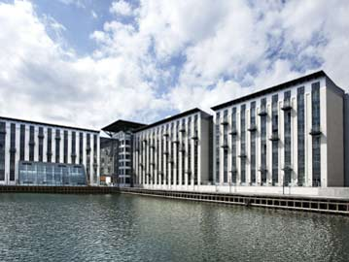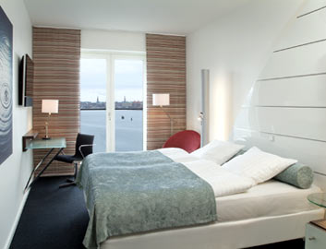

Must – Sees :
Tivoli :
Tivoli Garden is easily the best-known attraction in Copenhagen, and is located right next to the main train station for easy access for day-trippers from all over the country.
The garden was first established in 1843, inspired largely by the Vauxhall Gardens of Victorian London. The Tivoli is a far classier kind of affair, with the fairground attractions complemented by live music and cultural events. There are loads of venues contained within the park, all offering a range of live performances, many of which are free. There are also a number of highly regarded restaurants offering a range of cuisine covering all price ranges. The garden is especially wonderful at night, when parts of it are lit up by fireworks and thousands of lamps and paper lanterns.
Open: Sun-Wed 11h00-23h00; Thu & Sat 11h00-00h00; Fri 11h00-01h00 (Apr-Sep). The park opens in November and December for the Christmas Market. Admission: DKK75, adults; DKK35, children. Tel: +45 33-15-1001

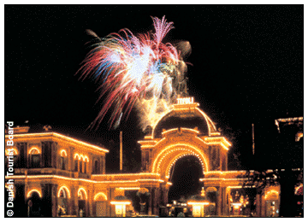

Amalienborg :
The city's main palace, Amalienborg, is made up of four identical rococo buildings surrounding the octagonal Amalienborg Square. Designed for four noble families of the 18th century the palaces are known individually as Christian VII's Mansion, Christian VIII's Mansion, Frederik VIII's Mansion and Christian IX's Mansion.The fantastic equestrian centrepiece is as much photographed as the palaces that surround it. Reigning monarch Queen Margrethe resides in Frederik VIII's mansion. When the Queen is at home you can see the guards changing in the square below with all the pomp of centuries of tradition.

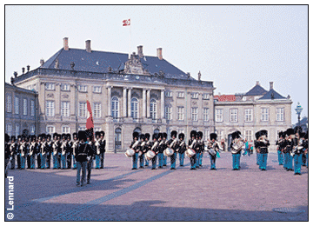

Rosenborg Castle :
Now lying in the heart of the city this was once a royal country estate retreat. King Christian IV originally built the castle in the early-17th century. The Renaissance style can clearly be seen in the building's architecture.
The castle is notably home to Denmark's Crown Jewels, which are on display in the treasure vaults. The building is now mainly a museum dedicated to the Royal Chronological Collections of paintings and artefacts relating to various periods in the Royal Family's history.
Rosenborg Slot. Voldgade 4. Open: Tue-Sun 11h00-14h00 (Jan-Apr & Nov-Dec); 11h00-15h00 (Oct); 10h00-16h00 (May & Sep); 10h00-17h00 (Jun-Aug). Admission: DKK65. Tel: +45 33-15-3286.

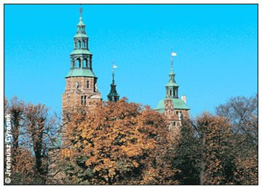

Excursions :
The Little Mermaid :
The Little Mermaid Statue is one of Copenhagen's most visited landmarks. It is located near the cruise ship pier of Langelinie. The sculpture was put up in 1913, and has since then been the symbol of Denmark. Like the Eiffel tower in Paris and the statue of liberty in New York both have been very important for the two cities, so has the Little Mermaid been important for Copenhagen!

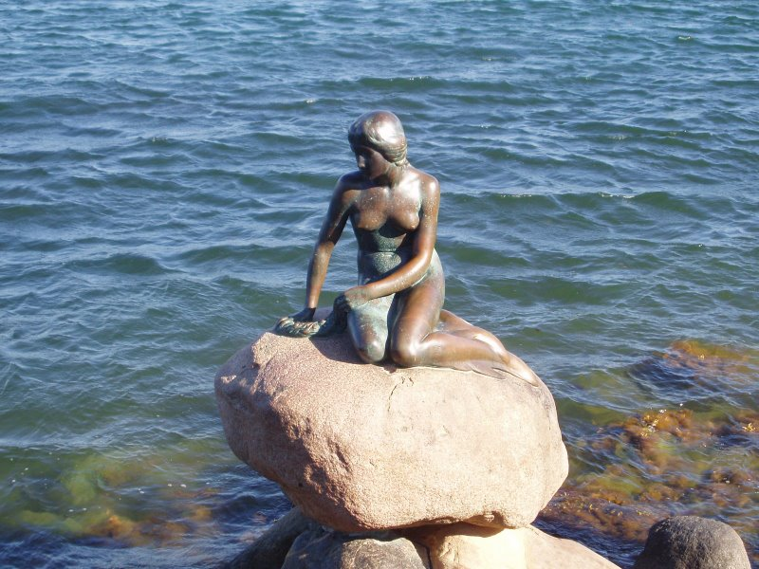

The Great Belt Suspension Bridge :
No matter where you are in Denmark it is worth deliberately scheduling an excursion that involves travelling over the Great Belt Suspension Bridge, undoubtedly one of the most impressive engineering feats of the last century anywhere in the world. The bridge's central span of 1624m is the second longest suspension bridge on earth and the complete bridge length of 6790m is just one part of the 18km road and rail connection between the islands of Funen and Zeeland.
The construction is truly amazing with higher towers than the famous Golden Gate in San Francisco. Driving over the Great Belt provides some of the most spectacular photo opportunities in Europe, particularly if the weather is fine when the views stretch across the sound between the two islands.

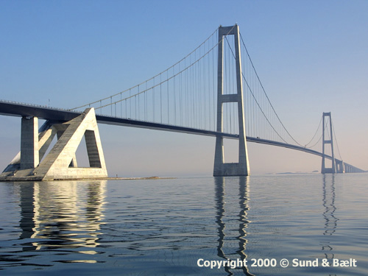

Odense :
On the island of Funen, Odense is most famous as being the city of Hans Christian Andersen, with the famous fairytale writer spending his formative years here. His childhood home is now open to visitors and is always a popular draw, while the Hans Christian Andersen museum contains many objects related to the writer as well as some rarer prints and samples of his books. But there is more to discover in Odense than this, the city has a fascinating history that is well worth discovering. The 14th-century cathedral is one of the most impressive Gothic structures in the nation.

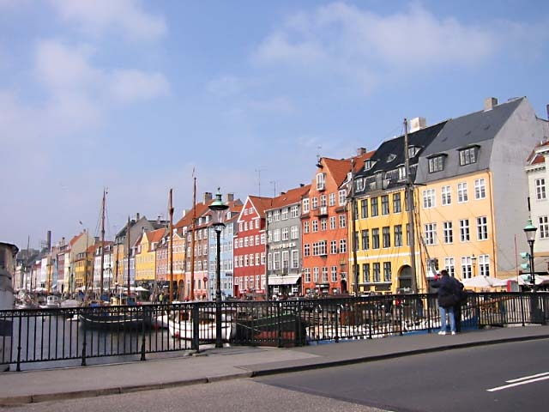

Roskilde and the Viking Ship Museum :
Once the capital of Denmark, Roskilde is Zeeland's only other city of note besides present day capital Copenhagen. The ancient city is still a picturesque town, particularly in the centre, and is dominated by the spectacular 14th-century Cathedral (Roskilde Domkirche), the resting-place for nearly 40 of Denmark's former Kings and Queens.
However the biggest draw for tourists is the Viking Ship Museum (Tel: +45 46-30-0200) with its centrepiece of five genuine Viking ships retrieved from the waters of the Roskilde fjord. A recent addition to the displays in the museum is the "Viking Island" where you can see Viking ships being made in the traditional manner by craftsmen.

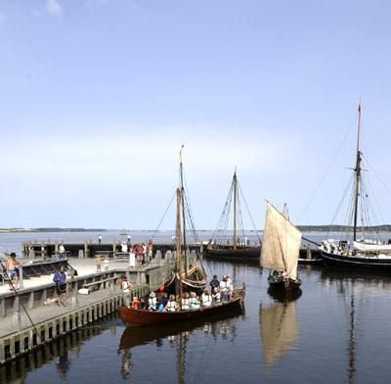

Helsingor :
On Zeeland lies Helsingor, one of the country's most interesting historic towns. The medieval buildings that form the main attractions include the Carmelite Monastery, widely regarded as one of the best-preserved 15th-century examples of the Gothic style in existence. You can also clearly see Sweden, barely a mile away across the sound, from the town.However, it isn't for its natural beauty or the medieval town centre that visitors flock to Helsingor, but for its castle Kronborg Slot - more popularly known as "Elsinore". Many people visiting believe this to be the Elsinore of Shakespeare's Hamlet, and certainly the magnificent Renaissance building.

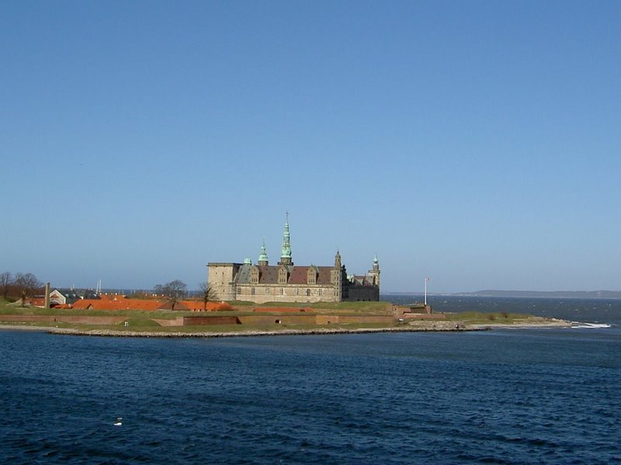

FOOD :
Denmark's most outstanding contribution to world cuisine is the smørrebrød, or open sandwich, which can be served with any number of "fillings" that are generally visually pleasing as well as tasting good. It's also worth trying the national dish of meatballs (frikadeller) with boiled or mashed potatoes.

INDIAN RESTAURANTS :
India Brasserie
38 Vesterbrogade, Copenhagen
Tel : 33 79 11 11

India Palace
13 H C Andersens Boulevard 13, Copenhagen
Tel : 33 91 04 08

Indian Taj
Jernbanegade 3-5, Copenhagen
Tel : 33 13 10 10

SHOPPING :
Best Areas
There is one place to shop in Copenhagen, and that's the Strøget - an impressive 3.2km-long pedestrianised thoroughfare made up of five streets. It is here where the main stores of Copenhagen are located, along with plenty of cafés for the foot-weary. At the top end of the Strøget you'll find the designer stores including Prada, Chanel and Gianni Versace among others. It is towards this end too that the massive edifice of Magasin is to be found, Northern Europe's biggest department store.
Towards the harbour lies the Royal District, an area of exclusive antique and furniture shops where only the rich can go with anything other than window shopping in mind. More exclusivity can be found off the Strøget in the Grønnegade quarter. Unique and quaint little stores abound, with the emphasis on clothing
Markets
The Tivoli Christmas Market is Copenhagen's most famous. For a whole month in the holiday season the gardens are turned into a massive festive market selling all manner of items. Coal braziers keep the shoppers warm as they wander round stalls selling tree ornaments, candle sticks and assorted Christmas knick-knacks. If you're after something specifically from Copenhagen, you should consider one or more of the following: Royal Copenhagen porcelain, Scandinavian Crystal and handknitted clothing.
Sweater Market is a good place to find handknitted Scandinavian style jumpers at knockdown prices and further along the Strøget there is more than one outlet selling both crystal and porcelain.
The other thing Denmark is famous for is the silver jewellery of Georg Jensen. The designer inspired a whole style of silvercraft and the shop that bears his name is the most famous silversmiths in the world.



